**Chapter 4 Quadratic Functions and Equations Test**

**Name: _______________________  
Block: ______________**

Factor the following. [L2]

$1.) m^{2}-3m-40$ 1. $2.) 8w^{5}-16w^{4}+20w$_________________  
  
  
 2._________________

Graph (Use at least 5 points). [L2] Graph (Use at least 5 points). [L2]

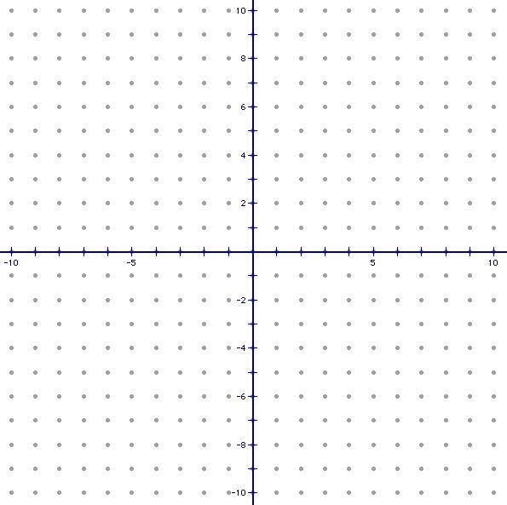

Factor the expression completely. [L2]

5.) x2 + 8x + 15 5._________________

6._________________

Simplify the following. [L2]

7.) $\sqrt{-36}$ 7.__________________

8.) $\sqrt{-}$ 81 8.__________________

9.) (7 + 2i) + (10 – 5i) 9.__________________

10.) (-9 – 7i) – (3 + 8i) 10._________________

11.) (3 + 5i)(2 – 4i) 11._________________

Solve the Equations Using Any Method (Factoring, Graphing, or Quadratic Formula). [L3]

12.) ${ x}^{2}=-15+8x$ 12._________________

13.) ${ 3x}^{2}+7x=9$ 13._________________

14.) ${ x}^{2}-4x+3=0$ 14._________________

15.) ${ 2x}^{2}-3=2x$ 15._________________

16.) ${ x}^{2}+5=4x$ 16._________________

Solve the following. [L4]  
17.) Your local bakery sells more bagels when it reduces price, but then its profit changes. The function 13.) ${ y=-1000x}^{2}+1100x-2.5$ models the bakery’s daily profit in dollars, from selling bagels, where x is the price of a bagel in dollars. What’s the highest price the bakery can charge, in dollars, and make a profit of at least $250?

17._________________

Solve the following. [L4]

$${ 18.) 5x}^{3}-140x={ 15x}^{2}$$

$18.____________________$